## Nielsen Heuristics Evaluation Form (make as many copies as you need)

**1. What screen of the UI are you looking at (attach/paste a picture/screenshot):**

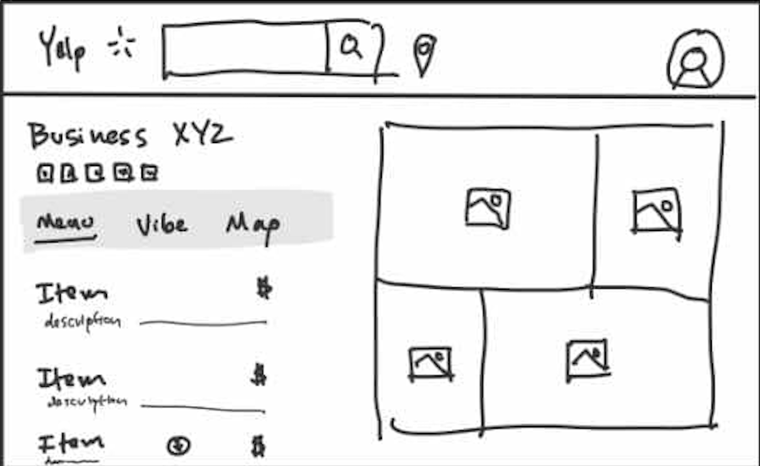

**2. Evaluate each heuristic below for this screen. Feel free to draw circles and arrows around the above screen shot.**

* Visibility of System Status:

**The interface provides clear status feedback by showing tabs like "Menu," "Vibe," and "Map" to indicate navigation options. However, there is no immediate indicator for system loading or processing user actions.**

* Match Between System and Real World

**The inclusion of categories like "Menu," "Vibe," and "Map" reflects real-world expectations for exploring a business's offerings and atmosphere. The use of icons and photos aligns with how users perceive and explore content in real life.**

* User Control and Freedom

**The navigation tabs offer some control for users to switch between sections. However, the design lacks undo or edit options for actions (e.g., ordering or navigating away accidentally).**

* Consistency and Standards

**The interface follows familiar patterns with tab-based navigation and a grid layout for photos. However, it could be more consistent in spacing and alignment, especially between the menu items and the photo grid.**

* Error Prevention

**There is no visible functionality to prevent errors, such as confirming user actions like navigating to another section. Tooltips or confirmation dialogs could help avoid accidental misclicks.**

* Recognition Rather Than Recall

**The design supports recognition by visually displaying menu items, photos, and navigation tabs. Users don't need to recall where information is located since it is presented upfront.**

* Flexibility and Efficiency of Use

**The design appears basic, catering primarily to novice users. There are no advanced options like filtering or sorting menu items, which could improve efficiency for experienced users.**

* Aesthetic and Minimalist Design

**The interface is clean and straightforward, focusing on essential elements like tabs, menu items, and photos. However, the spacing and alignment of components could be improved to enhance visual harmony.**

* Help Users Recognize, Diagnose, and Recover from Errors

**There are no visible mechanisms to help users diagnose or recover from errors, such as a help section or error messages. Adding these features would enhance the user experience.**

* Help and Documentation

**The design lacks any visible help or documentation. Adding a small help icon or brief instructions for each tab would assist users in navigating the interface more effectively.**